Project Planning Phase
Project Planning Template (Product Backlog, Sprint Planning, Stories, Story points)

Date | 15 February 2025
Team ID | LTVIP2026TMIDS65594
Project Name | Educational Organization Using ServiceNow
Maximum Marks | 5 Marks

Product Backlog, Sprint Schedule, and Estimation (4 Marks)
Use the below template to create product backlog and sprint schedule
Sprint | Functional Requirement (Epic) | User Story Number | User Story / Task | Story Points | Priority | Team Members
Sprint-1 | Registration | USN-1 | As a user, I can register for the application by entering my email, password, and confirming my password. | 2 | High | Team
Sprint-1 | Registration | USN-2 | As a user, I will receive confirmation email once I have registered for the application | 1 | High | Team
Sprint-2 | Registration | USN-3 | As a user, I can register for the application through Facebook | 2 | Low | Team
Sprint-1 | Login | USN-4 | As a user, I can register for the application through Gmail | 2 | Medium | Team
Sprint-1 | Login | USN-5 | As a user, I can log into the application by entering email & password | 1 | High | Team
Sprint-1 | Dashboard | USN-6 | As a user, I can view dashboard and academic details. | 3 | High | Team
Sprint-3 | Result Management | USN-7 | As a teacher, I can upload student marks. | 3 | High | Team
Sprint-3 | Notification System | USN-8 | As a student, I can view results. | 2 | Medium | Team

Project Tracker, Velocity & Burndown Chart: (4 Marks)
Sprint | Total Story Points | Duration | Sprint Start Date | Sprint End Date (Planned) | Story Points Completed (as on Planned End Date) | Sprint Release Date (Actual)
Sprint-1 | 20 | 6 Days | 24 Oct 2022 | 29 Oct 2022 | 20 | 29 Oct 2022
Sprint-2 | 20 | 6 Days | 31 Oct 2022 | 05 Nov 2022 | 11 | 20 Feb 2025
Sprint-3 | 20 | 6 Days | 07 Nov 2022 | 12 Nov 2022 | 7 | 26 Feb 2025
Sprint-4 | 20 | 6 Days | 14 Nov 2022 | 19 Nov 2022 | 11
  04 Mar 2025

Velocity:
Imagine we have a 10-day sprint duration, and the velocity of the team is 20 (points per sprint). Let’s calculate the team’s average velocity (AV) per iteration unit (story points per day)
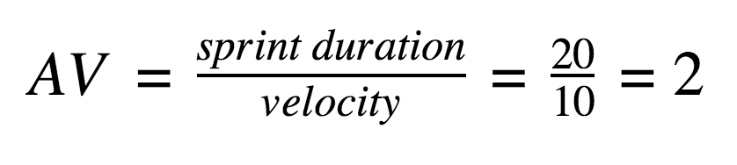

Burndown Chart:
A burn down chart is a graphical representation of work left to do versus time. It is often used in agile software development methodologies such as Scrum. However, burn down charts can be applied to any project containing measurable progress over time.

https://www.visual-paradigm.com/scrum/scrum-burndown-chart/
https://www.atlassian.com/agile/tutorials/burndown-charts

Reference:
https://www.atlassian.com/agile/project-management
https://www.atlassian.com/agile/tutorials/how-to-do-scrum-with-jira-software
https://www.atlassian.com/agile/tutorials/epics
https://www.atlassian.com/agile/tutorials/sprints
https://www.atlassian.com/agile/project-management/estimation
https://www.atlassian.com/agile/tutorials/burndown-charts

